Portfolio: Promotional Collaborations

Study association Dimensie
Cubicus B11
7500 AE Enschede
: +31 6 45 57 04 48
: board@svdimensie.nl
: www.svdimensie.nl
Study Association Dimensie
Dimensie has been the study association for psychology since 1981. The association offers its members the opportunity to develop personally and provides support within and outside the study programme. Dimensie organises study-related activities such as lectures, excursions, field days and symposia. Recreational activities are also offered to bring members into contact with each other inside and outside the lectures.

The University of Twente is an enterprising, innovative and technical university. Psychology at this university, partly due to the Twente Education Model, is practical, applied and uses the latest techniques in the field of education and research. Since the internationalisation of the University of Twente and within the association, the number of members has grown steadily. This academic year, 850 students are members of Dimensie. Furthermore, around 70 of our members are contributing actively in committees to the association.

As the study association for psychology, we want to offer our members more activities that fit their study and help them in their further career orientation. We, therefore, build on collaborations with external companies in order to provide more insight into different job fields. Of most interest is the provision of lectures, workshops, internships and vacancies.

Kind regards
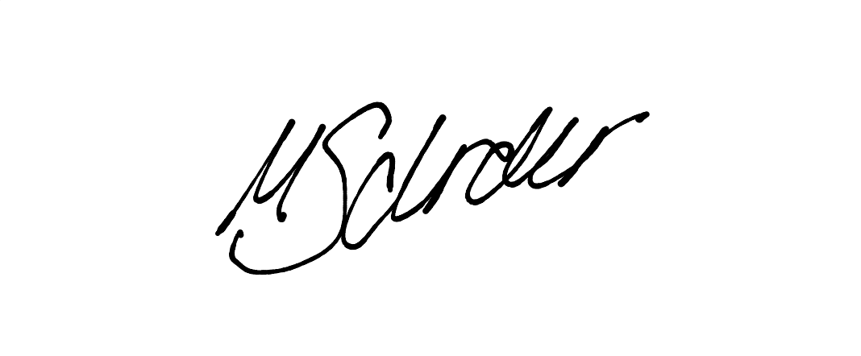

Marie Schröder
Commissioner of External Affairs

Cooperation Options
Through Dimensie you can gain brand awareness among more than 850 psychology students. Through Dimensies online and offline promotion, students from other studies and employees can also be reached in addition to the members of Dimensie.
By using the website, posters, flyers, slides on our television screen, and social media announcements (Whatsapp, LinkedIn, Instagram) you make our members aware of your organisation. Hence, your company is then getting in the interest of new, young and entrepreneurial students and potential employees. Channels with the largest reach are explained below.

Appearance in Association Room: ​​Flyers, Posters, and TV Screen
Because all lectures are given on campus, there is a lot of traffic in the buildings. Therefore, our association room offers a great possibility for the promotion of external parties. We have several walls to put up posters, we can spread flyers among our members and we also have a screen on which we can rotate slides with information of external partners.
There are different advertising spaces that we can offer for external parties:
- Hang up posters in the association room
- Put flyers in the association room
- Put up slides on our screen in the association room

Social Medias
The most influential tools over which we reach our members are our social media channels which include: Whatsapp chats, Instagram account, and a LinkedIn account. We can offer external companies to have an announcement via those channels.
- Whatsapp Announcement
Via our whatsapp group chats we inform our members mainly about interesting upcoming events from our association, as well as from external parties. Combining all channels on whatsapp we can reach up to 350 members.
- Instagram Announcement
Our Instagram account has been professionalised since August 2021 by our Internal Affairs and gives the option to inform about events, internships/ vacancies etc. per post or per story. We have around 800 followers, and with our postings we reach about 850 accounts within a month, which is constantly increasing.
- LinkedIn Announcement
Besides our other channels, the LinkedIn account is mainly used for vacancies, internships and career related opportunities for our members. With a post on our LinkedIn account external companies can reach students that are especially interested in career opportunities.
Website
The current website ‘svdimensie.nl’ is getting renewed regularly since it has been launched. On the website, members and interested parties can see which activities are being organised, view vacancies and profiles of partners and also read news about the association and the university.
There are different options that we offer for external parties:
- Spot on our partners website (logo + text) (‘career/partners’)
- Publication of external events (‘events/outside from Dimensie’)
- Publication of vacancies/ internships/ trainings (’career/vacancies’)

Price overview

Below are the sponsor options with associated prices. We offer sponsor packages for a specific period of time, but if you want something very specific, we are always open to discuss other options.

Package: General Partner Visibility (website + association room)
In this package we will make you visible as our partner on our website and give you a visible spot in our association room (posters, flyers, tv screen). We will also promote you once as a new partner on our LinkedIn website.

If you want the full package the options we offer are:

What we offer:  - Spot on website as partner (‘career/partners’)  - Present your poster in the association room  - Present your flyers in the association room  - Present you on our tv screen in the association room  - Promote you once on our LinkedIn | The prices:  Partner Package per month………..30€  Partner Package half year…………120€  Partner Package full year………….220€

You can also choose from specific advertising spaces only:

Logo + text under 'Career/Companies'
Per month….…..20€
Half year……….80€
Full year……….120€
Provide flyers + posters in our association room
Per month….…..30€
Half year……….120€
Full year……….180€
Present slide (logo + text) on the screen in our association room
Per month….…..30€
Half year……….120€
Full year……….180€‚

Package: Social Media StarterPack (website, social media channels: LinkedIn, Whatsapp, Instagram)
In this package we offer to advertise specific content (e.g. an event, internship, vacancy) once on our website (‘events/outside from Dimensie’/’career/vacancies’) as well as promote it on our other social media which includes: Instagram, Whatsapp, LinkedIn. Depending on the content of the message wanted to be spread among our members we might give suggestions which channel is best to use.

What we offer:  - Advertise content on our website (‘events/outside from Dimensie’ /’career/vacancies’)  - Advertise content on Instagram  - Advertise content on Whatsapp  - Advertise content on LinkedIn | The prices:  Social Media Starterpack……………. 30€

Note: We offer this service for external companies that want their content advertised once (Social Media Starterpack) but we also offer this service for a longer period of time, meaning that we can promote more content spread over a longer period of time (see: Partner Advertisement Advanced’ below).

Package: Partner Advertisement Advanced (website, social media channels: LinkedIn, Whatsapp, Instagram)

For companies that aim for a collaboration over a longer period of time we offer the ‘Partner Advertisement Advanced’ Package. Here we will promote you as our new partner on our website as well as on LinkedIn. Furthermore, whenever new content should be spread among our members (e.g.: events, internships, vacancies) we offer our social media channels: website, Instagram, Whatsapp, LinkedIn. Depending on the content of the message wanted to be spread among our members we might give suggestions which channel is best to use.

What we offer:  - Spot on our website as partner  - Promote you once on our LinkedIn as new partner  - Advertise content on our website (‘events/outside from Dimensie’ /’career/vacancies’)  - Advertise content on Instagram  - Advertise content on Whatsapp  - Advertise content on LinkedIn | The prices:  Advertisement Package one month…..50€  Advertisement Package half year…….150€  Advertisement Package full year……..250€

